TITLE: Movo -Social Network System Design Report
GROUP: Data Structures and Algorithms
MEMBERS:
Ariel Boutcher - BSCCS/2025/40350
Derrick Mburu - BSCCS/2025/40401
Ericson Karanja-BSCCS/2025/39563
Tinaelis Mumbi -BSCCS/2025/40091
Benie Machari -BSCCS/2025/39532
Brillian Andalo -BSCCS/2025/41447
Fridah Harawo -BSCCS/2025/35619
Loise Wambui - BSCCS/2025/40219
Grace Wanjiru - BSCCS/2025/39629
Rose Mateta - BSCCS/2025/39761

Date: 24/3/2026

1.Use Cases Generation
Movo is a simplified social networking platform that enables users to share short status updates, connect with others, and view a personalised feed of content from people they follow.
1.1. User management
- A user can register an account by providing username, email,bio, and password.
- A registered user can log in and log out of their account securely.
- A user can view and update their profile information.

1.2. Post

- A logged-in user can create a new post (status update).
- A user can view their own posts on their profile.
- A user can delete their own posts.
1.3.Timeline Feed

- A user can view a personalised timeline showing posts from accounts they follow,sorted by recent first.
- A user can view a public feed showing all posts on the platform.
1.4 Social Graph

- A user can follow another user.
- A user can unfollow a user they previously followed.
- A user can see who they are following and who follows them.
1.5 Search
- A user can search for other users by their username.

2.Constraints and Analysis

During the development of Movo, several constraints were identified that influenced the design and implementation decisions of the system.

Technical Constraints

The application was built using Djang, which limited the frontend flexibility compared to using a dedicated frontend framework such as React or Vue.
The platform relies on SQLite for local development, which is not suitable for high-traffic production environments.PostgreSQL is used when deployed on Horeku.
Media files such as images and videos are stored locally during development. On Heroku, the filesystem is ephemeral, meaning uploaded files are lost on dyno restart- this was addressed using Cloudinary for persistent media storage.

Functional Constraints

Post content is limited to a maximum of 280 characters, similar to Twitter's design.
User biography is limited to 160 characters.
Only registered and logged-in users can create posts,like,comment,follow,or interact with the platform.

DSA Constraints

The Graph, MaxHeap, and HashTable used in the application are custom-built from scratch in pure Python,meaning they do not benefit from the optimisations of built-in Python libraries.

3.System Overview

System Overview

Movo follows a Model-View-Template( MVT) architecture,which is Django’s variation of the traditional Model-View-Controller(MVC) pattern.The system is divided into distinct layers, each responsible for a specific part of the application.

Architecture Diagram
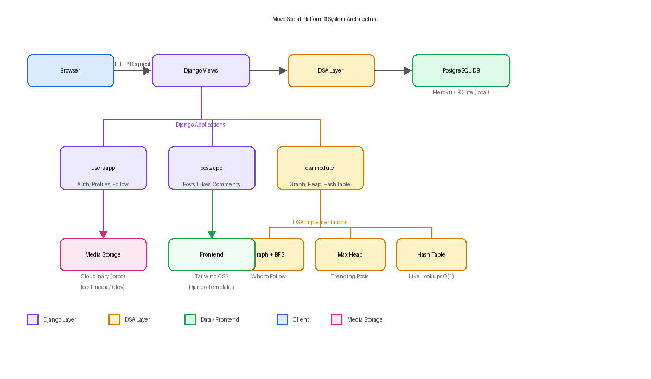
Application Modules
- User app - Handles user registration, login,logout,profile,management,and the follow/unfollow system.
- Post app - Manages the creation,deletion,liking,commenting,and reposting of content.
- DSA module - Contains the custom data structure implementations that power the recommendation engine, trending posts,and liked post lookups.

Database Design
The system uses the following core models:
- User - Stores username,email,bio,avatar,and website.
- Follow - Represents a directional relationship between two users (follower > following).
- Post - Stores post content,media files,and timestamps.
- Like - Records which user liked which post.
- Comment - Stores comments linked to a post and an author.
- Repost - Records which user reposted which post.

4. Data Structures and Algorithms

Directed Graph - Social Network Representation
A directed graph was implemented to model the social network within Movo.Each user in the system is represented as a node,and each follow relationship between users is represented as a directed edge.The graph is stored using an adjacency list implemented as a Python dictionary,where each key is a user ID and its value is a set of user IDs that the user follows.
- Time Complexity:O(1) for adding a user,o(1) for adding a follow,O(V+E) for BFS traversal
- Use Case:Powers the “Who tho Follow” recommendation widget on the feel page.

Breadth-First Search — “Who to Follow” Recommendations
Breadth-First Search (BFS) is applied to the social graph to generate user recommendations.Starting from the current user,BFS explores first-level connections(users they already follow),then second-level connections(users followed by those they follow).Candidates are ranked by how many mutual connections they share with the current user.
- Time Complexity:O(V+E)- visits each node and edge at most once.
- Use Case:Suggests relevant users to follow based on mutual connections

Binary Max-Heap —Trending Posts
A binary max-heap was implemented from scratch using a Python array. It is used to rank and retrieve the top trending posts on the Explore page.Each post is assigned a composite engagement score calculated as follows:
Engagement Score = Likes + (Comments × 2) + Recency Bonus Recency Bonus = max(0, 48 − hours since post) × 2
The max-heap ensures that the post with highest engagement score is always at the root,allowing efficient retrieval of the top N trending posts.
- Time Complexity:o(n log n) for building the heap,o(log n) per insertion.
- Use Case: Ranks posts on the Explore/Trending page.

Hash Table — Linked Post Lookups
A custom hash table was implemented using separate chaining for collision resolution. It is used to determine in O(1) time whether the currently logged-in user has already liked a specific post.When a user loads their feed or the explore page,all their liked post IIDs are loaded into the hash table,enabling fast lookups during page rendering.
- Hash Function:Polynomial rolling hash
- Collision Resolution:Separate chaining.
- Auto-resize:Doubles capacity when load factor exceeds 0.75.
- Time Complexity:o(1) average for lookups.
- Use Case:O(1) liked/reposted post lookup per post rendered on screen.

System Design Decision and Trade-offs
During the development of Movo,several key design decisions were made that influenced the overall architecture and performance of the system.Each decision involved weighing the benefits against the limitations given the scope and constraints of the project.

Django MVT Architecture
Django was chosen as the primary framework due to its built-in support for user authentication,ORM-based database management,and rapid development capabilities.The Model-View-Template(MVT) pattern provided a clean separation of concerns between the data layer,business logic,and presentation layer.However,a trade-off of this decision is that Django’s server-side rendering approach limits the interactivity of the fronted compared to a dedicated frontend framework such as React or Vue.

Custom DSA Implementations
The decision to implement the Graph,Max-Heap,and Hash Table from scratch in pure Python was made to demonstrate a practical understanding of data structure within a real application.While this approach serves the academic purpose of the project well,it comes with the trade-off that these custom implementations are not as optimised or battle-tested as Python’s built-in data structures and libraries.

Database Strategy
The decision to implement the Graph,Max-Heap,and Hash-Table from scratch in pure Python was made to demonstrate a practical understanding of data structures within real application.While this approach serves the academic purpose of the project well,it comes with the trade-off that these custom implementations are not as optimised or battle-tested as Python’s built-in data structure and libraries.

Database Strategy
SQLite was used during local development for its simplicity and zero-configuration setup.PostgreSQL was adopted for the production environment on Heroku due to its robustness and support for concurrent connections.This dual-database strategy introduced some complexity in configuration but ensured a smooth development workflow without compromising production reliability.

Media Storage
User-uploaded media such as profile avatars,post images,and videos are stored locally during development. In production on Heroku, Cloudinary was integrated for persistent media storage since Heroku’s filesystem is ephemeral — meaning any locally stored files would be lost on dyno restart.The decision ensured that user media persists reliably in the production environment.

Authentication and Security
Django’s built-in authentication system was used to handle user registration,login,and session management.All post creation,liking,commenting,and following actions are restricted to authenticated users through login-required decorators,ensuring that unauthenticated users cannot interact with the platform’s core features.

Conclusion
Movo is a fully functional social media platform that was developed using the Django framework as a part of a Data Structures and Algorithms course project.The platform successfully demonstrates how core DSA concepts can be applied in a real-world web application setting. A directed graph with BFS traversal powers the user recommendation system,a binary max-heap ranks trending posts by engagement score,and a custom hash table enable efficient liked post lookups in constant time.
Beyond the DSA implementations, the project also involved key software engineering decisions around database strategy,media,storage,deployment,and system architecture.These decisions reflect an understanding of both technical and practical constraints that influence real-world system design.

Overall,Movo served as a valuable exercise in bridging theoretical knowledge of data structures with practical software development,resulting in a deployable,fully featured social networking application.

References
- Jain,H.(2021).Problem Solving in Data Structure and Algorithms Using Python.Chapter 23 — System Design.
- Django Software Foundation.(2024).Django Documentation. https://docs.djangoproject.com
- Cloudinary.(2024).Cloudinary Documentation.
https://cloudinary.com/documentation
- Heroku.(2024).HerokuDev Center.https://devcenter.heroku.com

